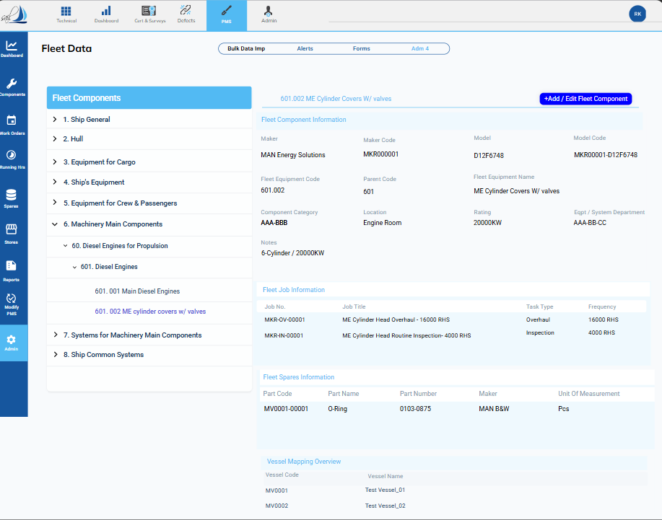

Fig 1
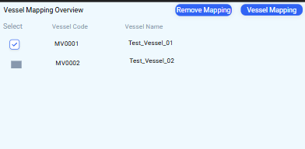
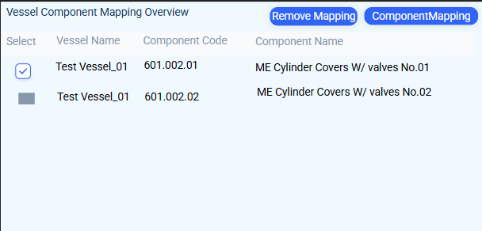

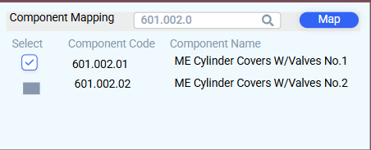
Fig 2 Fig 4

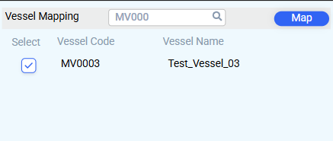
Fig 3 Fig 5

VESSEL MAPPING OVERVIEW GUIDE:
- Mapping Fleet Equipment Code with the Vessel
- Click on the Vessel Mapping Overview in Fig 1.
- The interface shown in Fig 2 will open.
- To remove equipment code mapping from a vessel, select the vessel from the list in Fig 2 and click on "Remove Mapping."
- To map a new vessel, click on the Vessel Mapping button in Fig 2.
- A popup window as shown in Fig 3 will open; select the vessel and click "Map."

- Mapping Fleet Equipment Code with the Vessel Component Code
- Click on the vessel name in either Fig 1 or Fig 2 for the vessel you want to link to the component code.
- The interface in Fig 4 will open, showing the list of component codes linked to the fleet equipment code.
- To unlink a component code, select the code and click on the "Remove Mapping" button in Fig 4.
- To map a new component code, click the component mapping button, which will open a popup as shown in Fig 5.
- The popup will display a list of component names and codes for the selected vessel.
- Select the correct component code and click the "Map" button in Fig 5.

